Sean D Kim, Ulani Qi

85-310 Draft Results Sections

Results

The experiment was a within-subjects study as each subject was exposed to all levels of the independent variables. Our goal was to investigate the effects of color and context on visual memory. The independent variables were duration (one or two seconds), image (object name with image or without image), and for image conditions the independent variables were color (black and white vs normal color) and context (normal background setting vs white background). The dependent measure was number of stimuli accurately recalled. The order that the stimuli was recalled did not matter. If a response was more specific than the stimulus (i.e. stimulus was flower, the person said daisy and it was a daisy) it counted as an accurate response, and if it was more general (i.e. stimulus was flower, the person said plant) it did not count. A total of 15 people participated in the experiment, and no participant’s data was thrown out. For the statistical analyses, we performed a repeated measures ANOVA on image and duration alone, as well as on all the independent variables (image, duration, image color and image context) together. An alpha level of 0.05 was used for all tests.

The first analysis we did was on the image and duration variables. The means and standard deviations are presented below in Table 1, as well as a graph of the means with error bars included (Figure 1). For image, we found that there was no significant difference whether the image existed or not, F(1,14) = 0.461, p = 0.508. We did however find a significant difference for the duration condition, F(1, 14)= 10.696, p = 0.006 < 0.05. For stimuli with a duration of one second, the average accurate recall rate was 0.29 which translates to 29% of stimuli presented, and for stimuli with a duration of two seconds, the average accurate recall rate was 0.363 which translates to 36.3% of stimuli presented. This shows a 7.3% increase in mean accurate recall rate as duration was increased from one to two seconds. We found no interaction between image and duration, F(1,14)=0.604, p = 0.450, which meant that a change in either image or duration had no significant effect on the outcome of the other variable.

We proceeded to analyze two independent variables (color and context) separately to check how each variable affects memory recall. First we looked at color and context given short duration, and then color and context given long duration. We did not find a significant effect for either conditions. With a short duration, the effects of color was not significant, F(1,14) = 0.013, p = 0.910; the effects of context was not significant, F(1,14) = 0.082, p = 0.779; and the interaction between the variables was not significant as well, F(1, 14) = 2.901, p = 0.111. With a long duration, color was again not significant, F(1, 14) = 0.453, p = 0.512; context also was not significant, F(1, 14) = 0.082, p = 0.779; and the interaction was also not significant, F(1,14) = 0.217, p = 0.649. Thus, contrary to our hypothesis, we did not see any significance in both variables.

We then performed an ANOVA using the three independent variables duration, color, and context. Once more, we didn’t find a significant effect. The significance for color was F(1,14) = 0.080, p = 0.781 and for context was F(1,14) = 0.163, p = 0.693. The interaction variable between color and context was also not significant, as its analysis was F(1,14)=1.522, p = 0.238. There wasn’t a significant effect either between color, context and duration F(1,14)=0.588, p = 0.456, or color and duration F(1,14) = 0.226, p = 0.642, or context and duration F(1,14) = 0.006, p = 0.939. Because of these findings, we can conclude that none of the factors had a significant effect on memory recall of 20 stimuli.

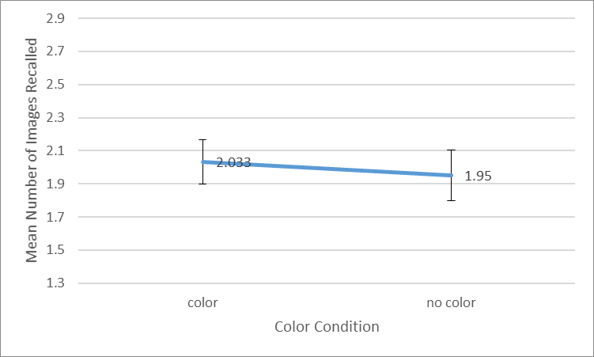

Figure . Mean number of correct image recalls by color condition. Error bars color=0.133, error bars no color=0.153

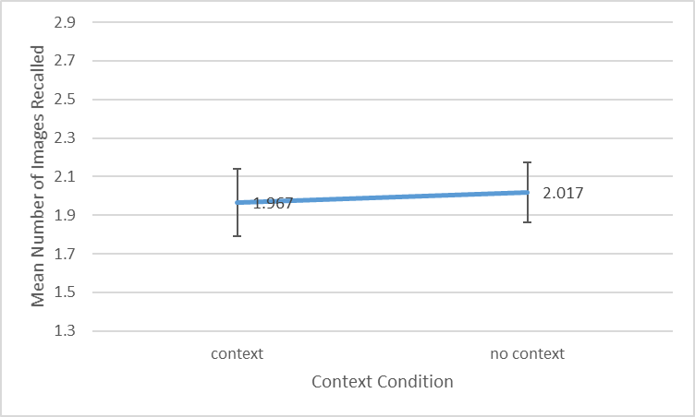

Figure . Mean number of correct image recalls by context condition. Error bars context=0.174, error bars no context=0.155

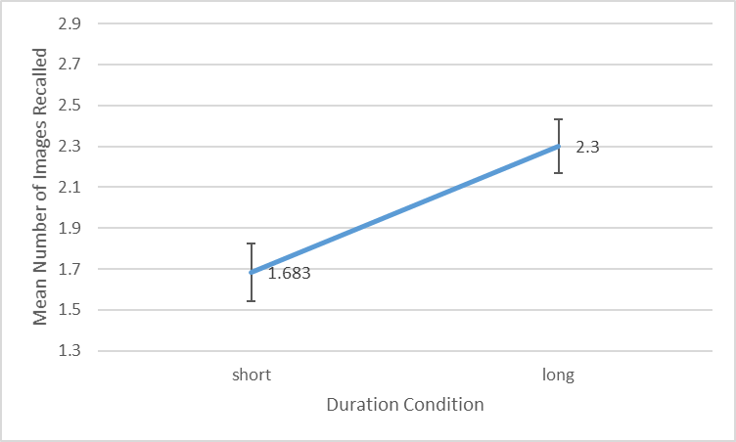

Figure . Mean number of correct image recalls by duration. Error bars one second=0.143, error bars two seconds=0.132

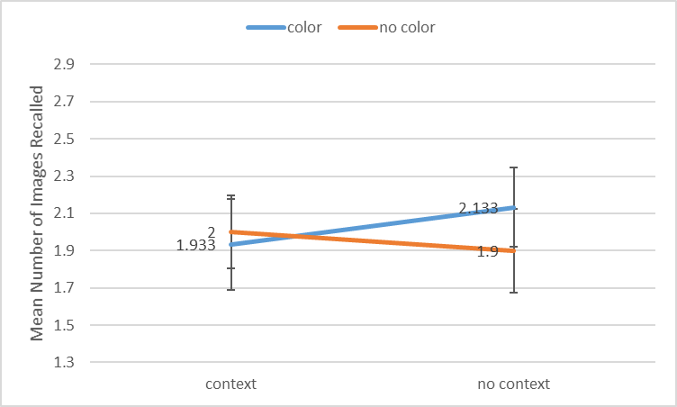

Figure . Mean number of correct image recalls by color and context. Errors: color and context=0.194, color no context=0.226, no color and context=0.244, no color and no context=0.214

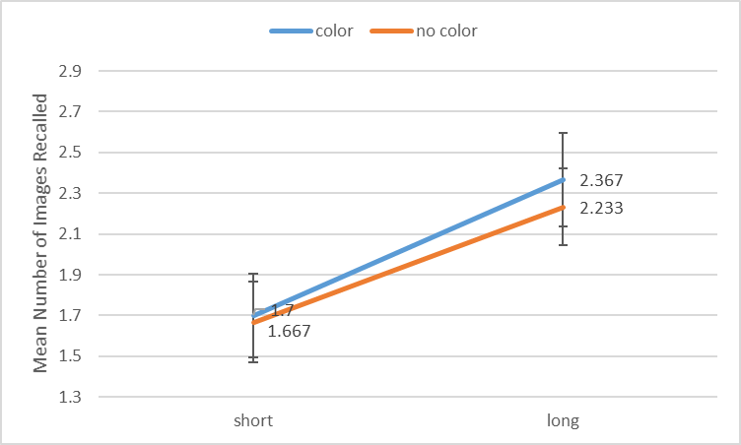

Figure . Mean number of correct image recalls by color and duration. Errors: color one sec=0.206, color two secs=0.231, no color one sec=0.199, no color two secs=0.188

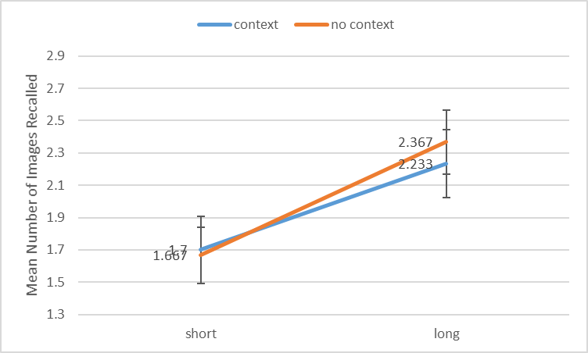

Figure . Mean number of correct image recalls by context and duration. Errors: context one sec=0.206, context two secs=0.212, no context one sec=0.174, no context two secs=0.198

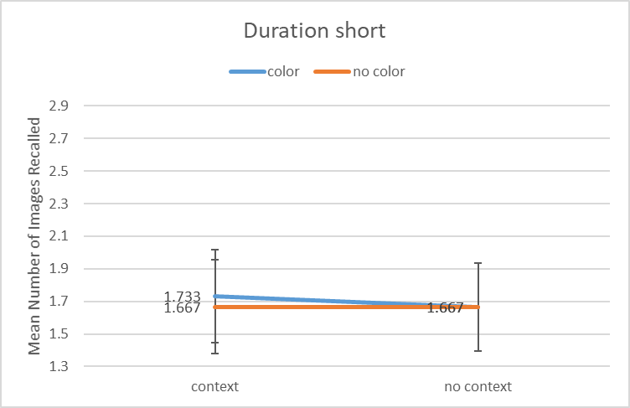

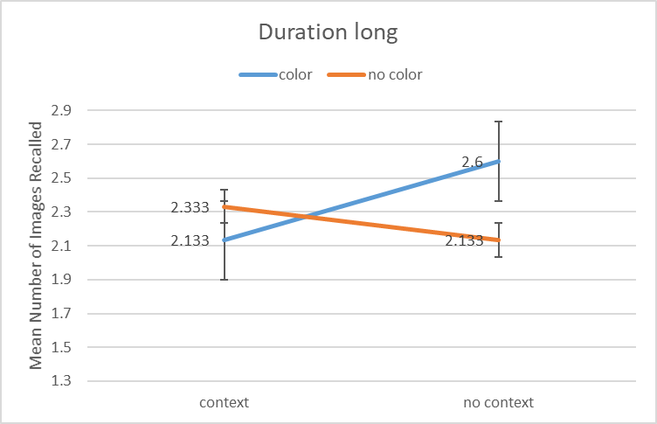

Figure . (Top) Mean number of correct image recalls by color and context, given duration one sec. Errors: color and context=0.284, color and no context=0.27, no color and context=0.287, no color and no context=0.27. (Bottom) Mean number of correct image recalls by color and context, given duration two secs. Errors: color and context=0.291, color and no context=0.349, no color and context=0.27, no color and no context=0.236.

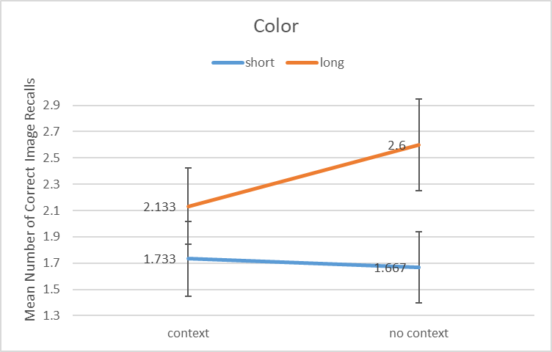

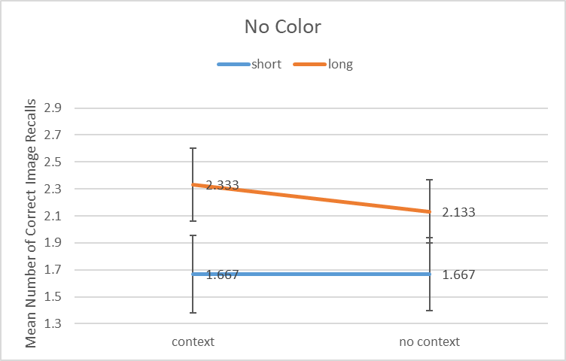

Figure . (Top) Mean number of correct image recalls by duration and context, given color. Errors: short context=0.284, short no context=0.27, long context=0.291, long no context=0.349. (Bottom) Mean number of correct image recalls by duration and context, given no color. Errors: short context=0.287, short no context=0.27, long context=0.27, long no context=0.236.

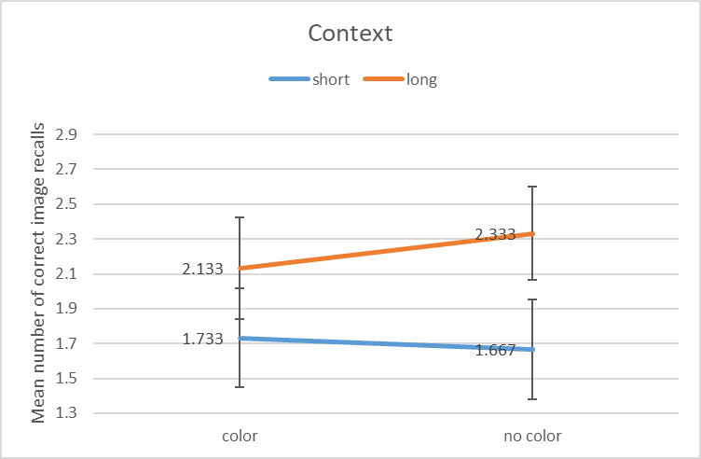

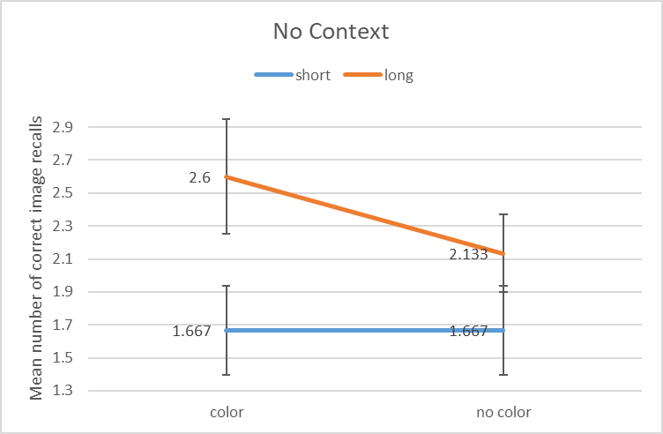

Figure . (Top) Mean number of correct recalls by duration and color, given context. Errors: short color=0.284, short no color=0.287, long color=0.291, long no color=0.27. (Bottom) Mean number of correct recalls by duration and color, given no context. Errors: short color=0.27, short no color=0.27, long color=0.349, long no color=0.236.